Seeds of Faith

St. Thomas the Apostle Religious Education Fall Digest
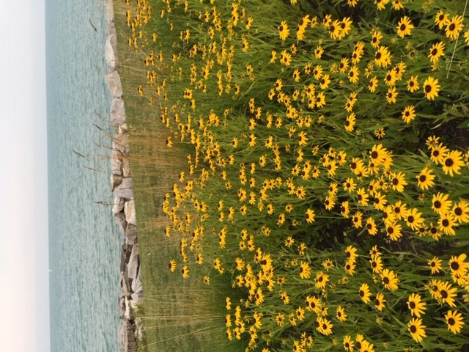
We are busy preparing for your return! Classes will be starting on September 17/18. We run 3 different pathways to participate in our Religious Education program (traditional RE classroom, home study, or family faith). Each option has a unique calendar. Please check the calendar on our webpage or find the link further down in this newsletter that corresponds to the pathway that you chose for your child. Afternoon sessions start at 4:30pm in the Pierson Street Church. Children may be dropped off after 4:15pm. Classes will conclude at 5:45pm. Students in preschool, Kindergarten, and 1st grade should be picked up at the child’s classroom. Please fill out a pickup authorization on the first day of class. Older students will be dismissed to meet in the courtyard.
Sacramental preparation is a two year process, with reception of the sacrament at the end of the two years. There are two Parent Events held on Sunday evenings. Please check the “Save the Dates” tile on the RE webpage.
Our Religious Education programming is reliant on volunteers willing to share their time and talents with our children. Please take time to prayerfully consider if you are being called to help make a difference in the classroom or in a support role this year. We need volunteers across all our programs and offer different ways to give back and support our students. We provide training, support and materials. You provide a love of God, His children, a desire to share the faith and your time. The Holy Spirit will do the rest. If working directly in the classroom is not your cup of tea...you can still make a difference by being a prayer coach or even helping with safety. We need door monitors to act as safety monitors during class times and we also need people to welcome the students and check them in as they arrive. Many people who volunteer to be door monitors bring a book to read or computer work to complete while they serve. Please contact the RE office to volunteer. The more people willing to help out, the less often you will need to serve.
Looking forward to some upcoming events in the RE program, we will have our 6th grade Bible Ceremony on Tuesday, October 15 and Wednesday, October 16 immediately following the opening priest’s presentation at approximately 4:45pm. Parents are welcome to attend and bring their cameras!
Second year students that are preparing to make their First Reconciliation this year in November will have an opportunity to select their preferred date after the parent meeting on Sunday, September 29th. We will be offering First Reconciliation on Thursday, November 14th or Monday, November 18th. Please make your date selection prior to October 25th. We also need you to provide information on where your child was baptised. Click here to provide your Baptismal Information. Parents are encouraged to assist their child in learning the Act of Contrition prior to reception of the sacrament in November. Contact the RE office if you have any questions.
The Catholic Church strongly believes that parents are the first and best teachers of their children. We are here to support you as you pass on the gift of faith to your children. Practice of the faith through weekly Mass attendance and daily prayer will go along way in preparing your children for the challenges that await them throughout their life. Click here to find the prayers your children should be familiar with by grade level.

Service Projects - Being His Hands and Feet
Serving our local community in HIS NAME!
These are the service projects that we anticipate doing this year:
- Pre-school students will make hugs to send to the elderly in local nursing homes.
- Kindergarten and first grade students will make Thanksgiving placemats to be distributed through the McHenry County Meals on Wheels program.
- Our second grade students will be sending Valentine greetings to our Veterans.
- Our third grade students will be collecting new and gently used socks, hats and gloves for the homeless to be distributed at a soup kitchen in Chicago.
- Our fourth and fifth grade students will be collecting donations of onesies, and diaper wipes for First Way Pregnancy Center in Johnsburg.
- Our sixth grade students will be doing a service project within the RE department as they help to serve dinner and clean up for our Family Faith Formation program.
- We will also have our annual Souper Bowl for the Food Pantry in January.
How will your family show Mercy this year?

Corporal Works of Mercy Spiritual Works of Mercy
Feed the hungry Advising the Sinner
Give drink to the thirsty Instructing the ignorant
Bury the dead Counseling the doubtful
Clothe the naked Comforting the sorrowful
Visit the sick Forgiving all injuries
Shelter the homeless Bearing wrongs patiently
Pray for the living and the dead

Calendars
Religious Education
Home Study
Family Faith Formation

No doubt about it, we are on a MISSION…
Be part of our mission to witness to the children of St. Thomas the Apostle about our loving Father! Plant seeds of faith and watch them bloom. We have openings for catechists at most grade levels and days/times. We would enjoy the opportunity to discuss being part of our team. Call the office for more information. 815 455-9787 or email us at: re@stthomascl.church

READ MORE ON OUR WEBSITE

